_________________________________________________________________________________

PRESS RELEASE FOR IMMEDIATE RELEASE
_________________________________________________________________________________

FOCUS EXPANDS RELIEF EFFORT FOR VICITIMS OF CYCLONE GAFILO IN MADAGASCAR TO HEALTH AND EDUCATION NEEDS

Antananarivo, Madagascar, 26 March, 2004 – Focus Humanitarian Assistance (FOCUS), an affiliate of the Aga Khan Development Network, has decided to expand its emergency relief intervention into education and health care support to serve some of the more than 200,000 people affected by Cyclone Gafilo in northern Madagascar. This intervention is part of the commitment of US$100,000 made by His Highness the Aga Khan in his message of sympathy to President Marc Ravalomanana following the cyclone.

Responding to urgent needs, FOCUS—in partnership with the Conseil National de Secours (CNS), (the Government of Madagascar’s national disaster agency), Catholic Relief Services, UNICEF and other agencies—has already transported provisions and education support material by truck and boat to some of the most remote parts of Majunga province.

“Work has commenced on responding in a preventive manner to the very high risk of widespread water-borne disease, in coordination with other local and international agencies, said Mr. Pinou Cheraly, FOCUS’s representative in Majunga, “we have already begun to identify needs in the education sector and to plan solutions involving targeted material assistance.”

Cyclone Gafilo made landfall near the city of Antalaha in Antsiranana province with winds averaging 300 kilometres per hour battering the northern part of Madagascar less than a month after Cyclone Elita swept a similar path killing 29 people.

FOCUS, whose experience includes responses to similar major cyclones in Mozambique (in 2000) and in Pakistan (in 1999), last intervened in Madagascar during a cholera outbreak in 1999.

For further information, please contact:

Pinou Chéraly
Focus Assistance Humanitaire
Madagascar
Telephone : +261 20 22 385 13

OR

Salim Sumar
Focus Humanitarian Assistance Europe Foundation
Fax : +44 208 655 16 49
E-mail : salim.sumar@focushumanitarian-europe.org
Website : www.akdn.org

NOTES

Focus Humanitarian Assistance (FOCUS) is an international group of agencies established in Europe, North America, and South and Central Asia that have developed a specialisation in disaster preparedness, mitigation, prevention and disaster response.

FOCUS is an affiliate of the Aga Khan Development Network. The Network is a group of private, non-denominational development agencies and institutions that seek to empower communities and individuals, often in disadvantaged circumstances, to improve living conditions and opportunities in specific regions of Africa and Asia. Active in over 30 countries, the Network's underlying impulse is the ethic of compassion for the vulnerable in society and its agencies and institutions work for the common good of all citizens, regardless of origin, gender or religion.
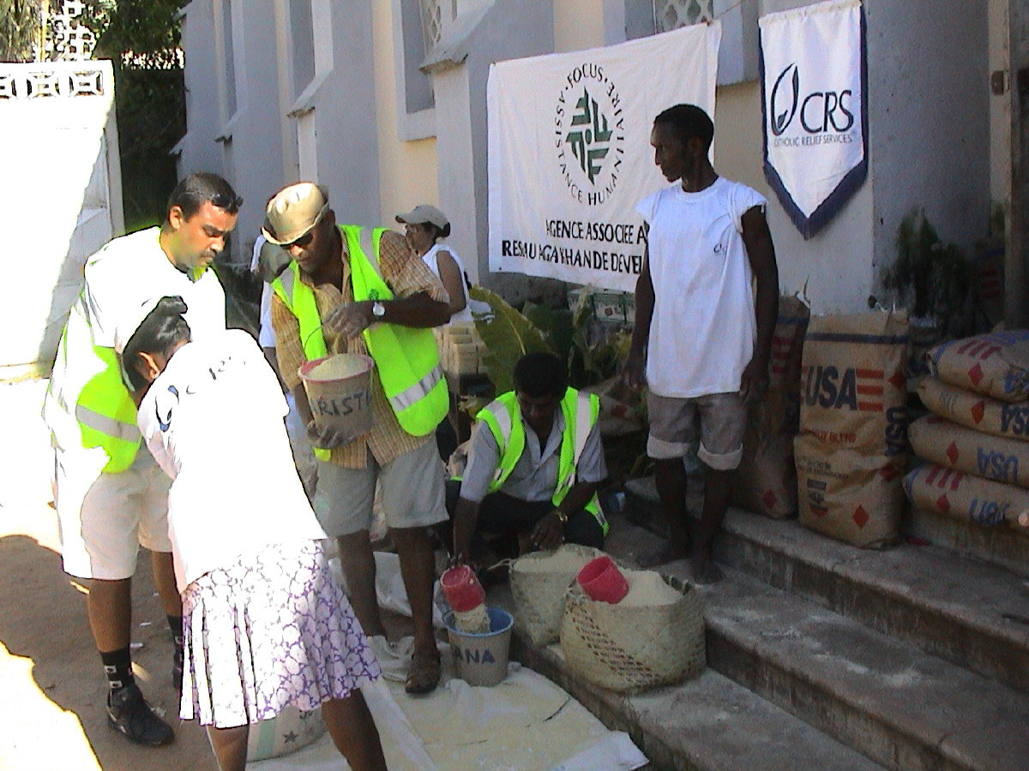

FOCUS volunteers commence distribution of essential items in Marovuoy.
© FOCUS

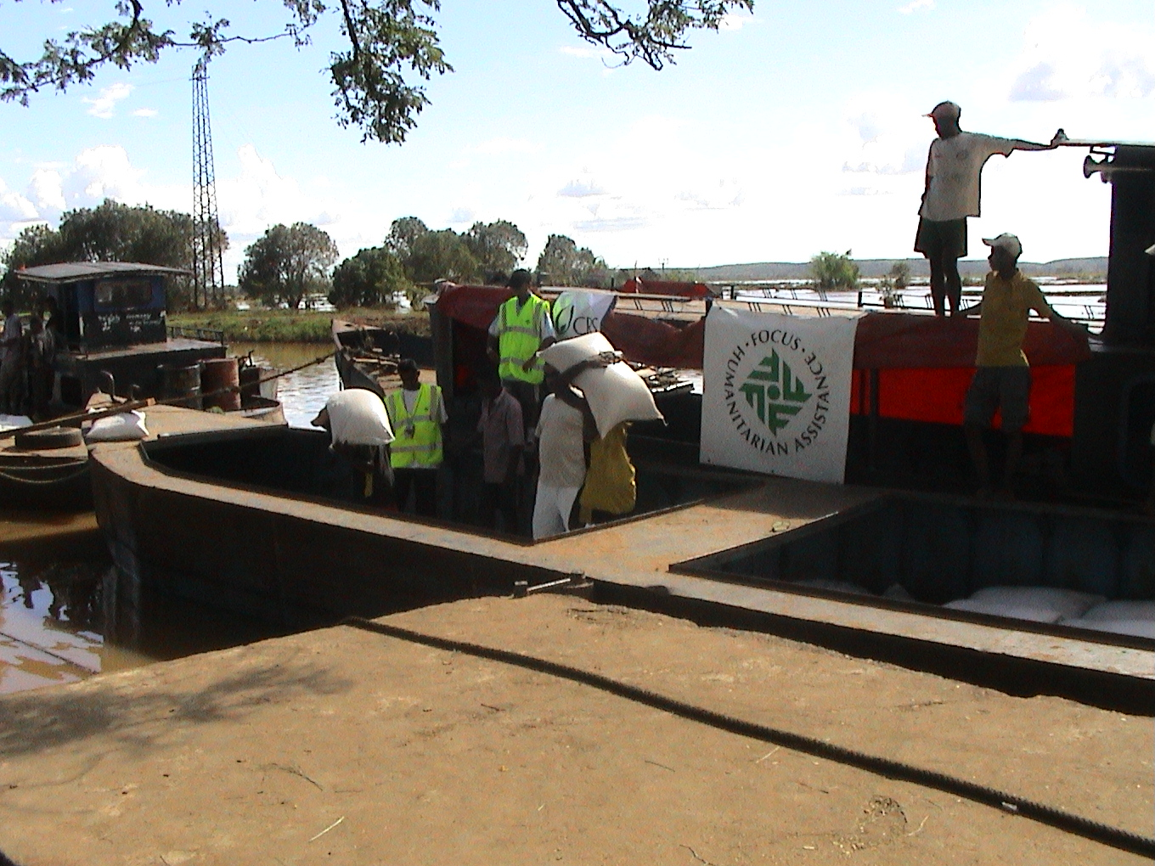

Barges being loaded at Marovouy for distribution by FOCUS in Ambato Bay and Madirovalo.
© FOCUS

