 **Restricted**  **Official Programme**

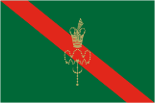

REPUBLIC OF KENYA

**PROGRAMME**

for the

**Official Visit to Kenya**

by

His Highness Prince Shah Rahim,

Aga khan V

from

**Monday 25th to Thursday 28th August 2025**

**NAIROBI KENYA**

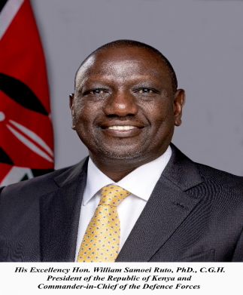

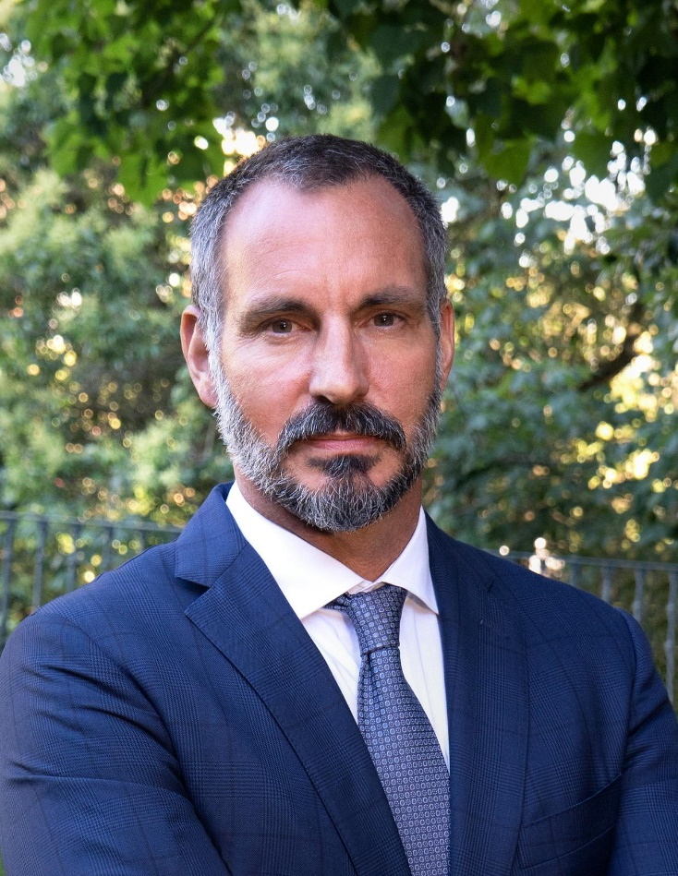

His Highness Prince Shah Rahim, Aga khan V

Table of Contents

PROGRAMME 1-3

The Escort of Honour 4

Protocol Officers 4

# PROGRAMME

**Day I –Monday 25th, AUGUST 2025**

|  |  |  |
| --- | --- | --- |
| *S/No* | *Time* | *Event* |
| 1. | 1530 Hrs | Hon. Musalia Mudavadi, E.G.H., Prime Cabinet Secretary and Cabinet Secretary, Ministry of Foreign and Diaspora Affairs, accompanied by the Escort of Honour Hon. Aden Duale, Cabinet Secretary of Health, arrives at Jomo Kenyatta International Airport (JKIA), Nairobi, State Pavilion. |
| 2. | 1600 Hrs | The plane carrying His Highness Prince Shah Rahim, Aga khan V, lands at Jomo Kenyatta International Airport (JKIA) and proceeds to the parking bay. |
| 3. |  | The Chief of Protocol of the Republic of Kenya boards the aircraft of His Highness Prince Shah Rahim, Aga khan V. |
| 4. |  | His Highness Prince Shah Rahim, Aga khan V, is received by Hon. Musalia Mudavadi, E.G.H., Prime Cabinet Secretary and Cabinet Secretary, Ministry of Foreign and Diaspora Affairs and the Escort of Honour Hon. Aden Duale, Cabinet Secretary of Health. |
| 5. |  | * **Arrival – Troops in Line.** |
| 6. |  | His Highness Prince Shah Rahim, Aga khan V is invited to sign the Distinguished Visitors’ Book at the State Pavilion. |
| 7. |  | * **Brief Sojourn at State Pavilion.** |
| 8. | 1645 Hrs | His Highness Prince Shah Rahim, Aga khan V, accompanied by the Escort of Honour Hon. Aden Duale, Cabinet Secretary of Health, departs Jomo Kenyatta International Airport (JKIA), State Pavilion for his Residence in Muthaiga. |
| 9. | 1700 Hrs | His Highness Prince Shah Rahim, Aga khan V, accompanied by the Escort of Honour Hon. Aden Duale, Cabinet Secretary of Health, arrives at his Residence in Muthaiga. |
| 10. |  | * **Installation at Residence.** * **Private Evening** |
| 11. |  | * **Overnight Stay** |

|  |  |  |
| --- | --- | --- |
| **DAY II – Tuesday 26th, AUGUST 2025** | | |
| 12. |  | * **Private Breakfast** |
| 13. | 0940 Hrs | His Highness Prince Shah Rahim, Aga khan V accompanied by the Escort of Honour Hon. Aden Duale, Cabinet Secretary of Health, departs his Residence in Muthaiga for State House, Nairobi. |
| 14. | 1000 Hrs | His Highness Prince Shah Rahim, Aga khan V, accompanied by the Escort of Honour Hon. Aden Duale, Cabinet Secretary of Health, arrives at State House, Nairobi and is received by His Excellency Dr. William Samoei Ruto, C.G.H., President of the Republic of Kenya and introduced to senior Kenyan Government Officials. |
| 15.  16  17.  18  19.  20. |  | National Anthem of the Republic of Kenya, and the East African Community Anthem are played.   * **Official photograph**   His Highness Prince Shah Rahim Al-Hussaini, Aga khan V, signs the Distinguished Visitors’ Book.  His Excellency the President of the Republic of Kenya invites His Highness Prince Shah Rahim, Aga khan V for a tête-á-tête in his office at State House.  Expanded talks   |  |  |  | | --- | --- | --- | | 14. |  |  | | 15. |  | * **Investiture Ceremony for His Highness**   **Prince Shah Rahim AI-Hussaini, Aga**  **Khan V**   * **Signing of Agreements/MoUs** | | 16. |  | * **Retreat.** | |  |  |  | |
| 21. | 1300 Hrs | Luncheon hosted by His Excellency Dr. William Samoei Ruto, C.G.H., President of the Republic of Kenya in honour of His Highness Prince Shah Rahim, Aga khan V |
| 22. |  | * **End of Luncheon** |
| 23. | 1400 Hrs | His Highness Prince Shah Rahim, Aga khan V accompanied by the Escort of Honour Hon. Aden Duale, Cabinet Secretary, Ministry of Health, departs State House for his Residence in Muthaiga. |
| 24. | 1420 Hrs | His Highness Prince Shah Rahim, Aga khan V accompanied by the Escort of Honour Hon. Aden Duale, Cabinet Secretary of Health, arrive at his Residence in Muthaiga. |
| 25. |  | * **Installation at Residence** |
| 26.  27.  28. |  | * **Private Programme**   **DAY III – Wednesday 27th, AUGUST 2025**   * **Private Breakfast** * **Separate Programme**   **DAY IV – Thursday 28th, AUGUST 2025**   * **Private Breakfast** |
| 29. | 0930 Hrs | His Highness Prince Shah Rahim, Aga khan V accompanied by the Escort of Honour Hon. Aden Duale, Cabinet Secretary of Health, departs his Residence in Muthaiga for Jomo Kenyatta International Airport (JKIA), State Pavillion. |
| 30. | 1000 Hrs | His Highness Prince Shah Rahim, Aga khan V accompanied by the Escort of Honour Hon. Aden Duale, Cabinet Secretary of Health, arrives at Jomo Kenyatta International Airport(JKIA), State Pavillion. |
| 31. |  | * **Departure Ceremonies** |
| 32. | 1030 Hrs | His Highness Prince Shah Rahim, Aga khan V departs the Republic of Kenya aboard a special aircraft.  **END OF PROGRAMME** |
|  | | |

# The Escort of Honour

# Hon. Aden Duale,

# Cabinet Secretary of Health

# Protocol Officers

Mr. Mike Maiyo – Protocol Officer

Tel: +254727357565

Ms. Betty Karwitha- Protocol Officer

Tel: +254718117418